# C# Web Development Basics – Regular Exam

# PANDA

**PANDA** (**P**ackage **A**cceptance and **N**ational **D**elivery **A**pplication) is a platform for package deliveries, which is a fast-rising Start-Up, which lacks a web application. You have been employed by the **KFC** (**K**ung-**F**u-**C**hicken) Corporation to implement a web platform for **PANDA**. However, there are specific requirements that must be followed.

## Technological Requirements

* Use the SIS.WebServer
* Use the SIS.Framework or the Niki.Framework
* Use Entity Framework Core

The Technological Requirements are **ABSOLUTE**. If you **do not follow** them, you will **NOT** be scored for other Requirements.

Now that you know the Technological Requirements, let us see what are the Business Requirements.

## Database Requirements

The **Database** of the PANDA application needs to support **3 entities**:

### User

* Has an Id – a GUID String or an **Integer**.
* Has an Username
* Has a Password
* Has an Email
* Has an Role – can be one of the following values (“User”, “Admin”)

### Package

* Has an Id – a GUID String or an **Integer**.
* Has a Description – a string.
* Has a Weight – a floating-point number.
* Has a Shipping Address – a string.
* Has a Status – can be one of the following values (“Pending”, “Shipped”, “Delivered”, “Acquired”)
* Has an Estimated Delivery Date – A DateTime object.
* Has a Recipient – a User object.

### Receipt

* Has an Id – a GUID String or an **Integer**.
* Has a Fee – a decimal number.
* Has an Issued On – a DateTime object.
* Has a Recipient – a User object.
* Has a Package – a Package object.

Implement the entities with the **correct datatypes**.

## Template Requirements

### Guest Templates

These are the **templates** and **functionalities**, accessible by Guests (**logged out** users).

#### Index Template (route = “/Home/Index”) (logged out user)

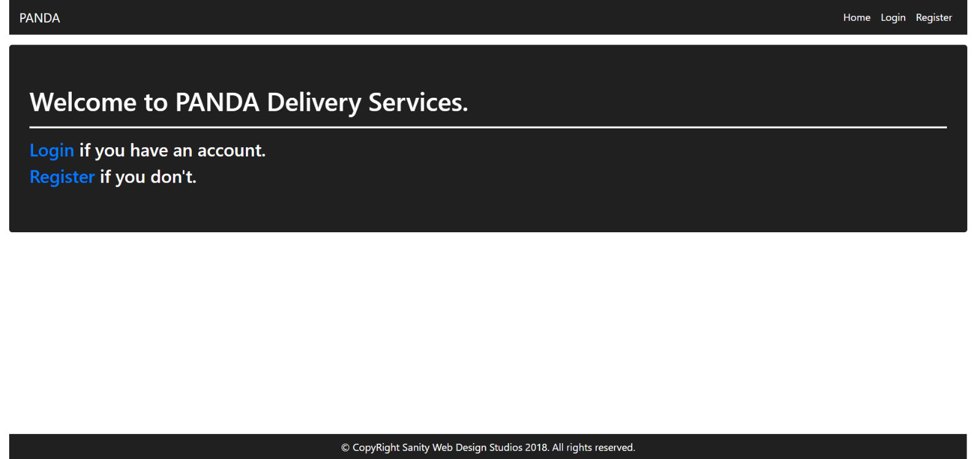

#### Login Template (route = “/Users/Login”) (logged out user)

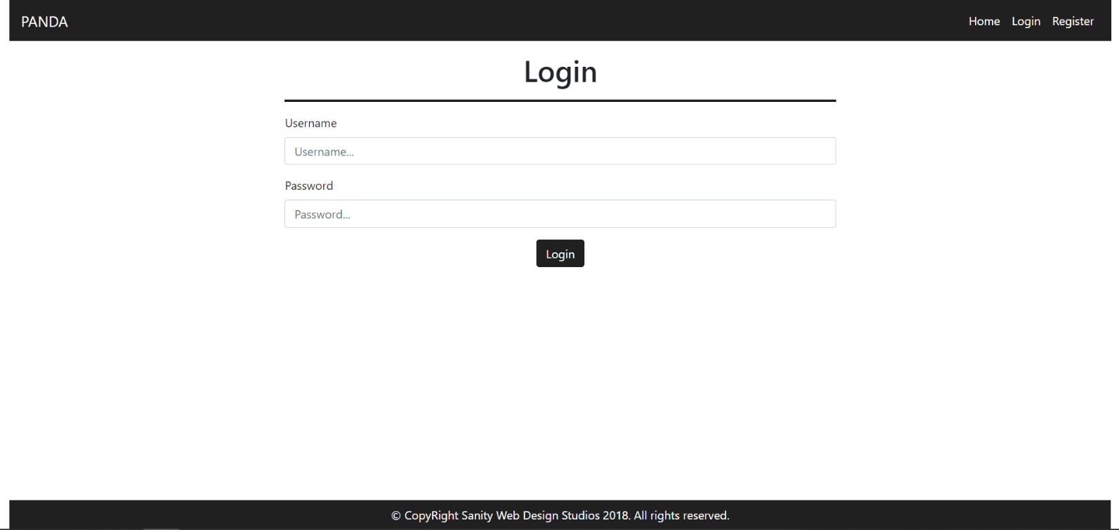

#### Register Template (route = “/Users/Register”) (logged out user)

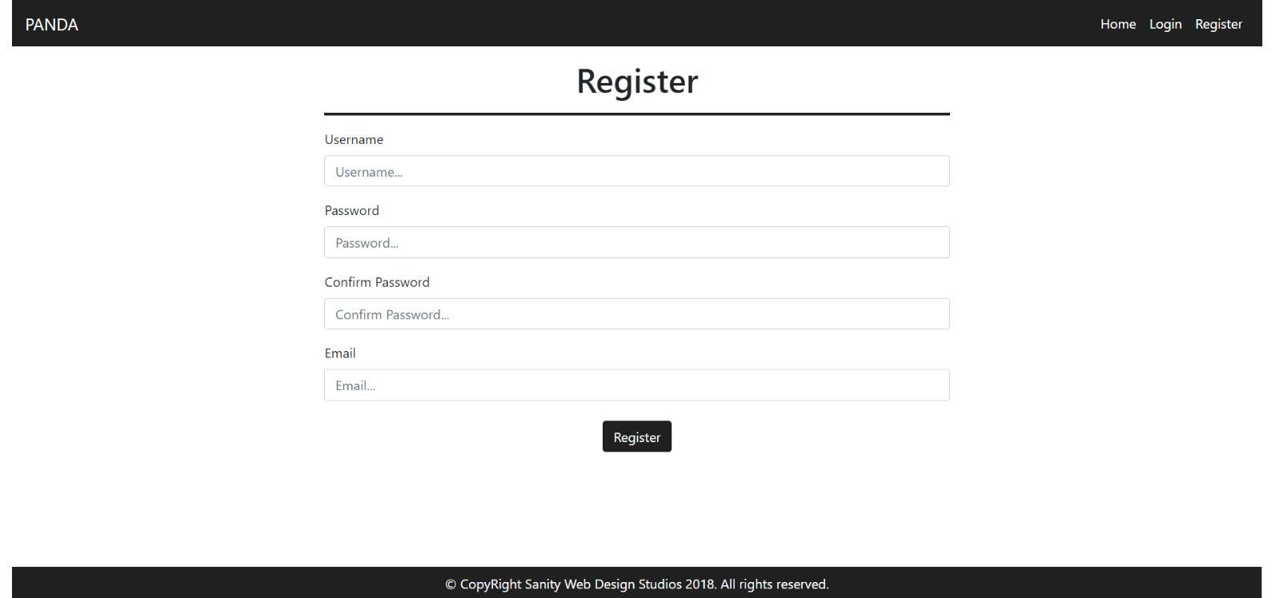

### User Templates

These are the **templates** and **functionalities**, accessible by Users (**logged in** users with Role - User).

#### LoggedIn Index Template (route=”/Home/Index”) (logged in user)

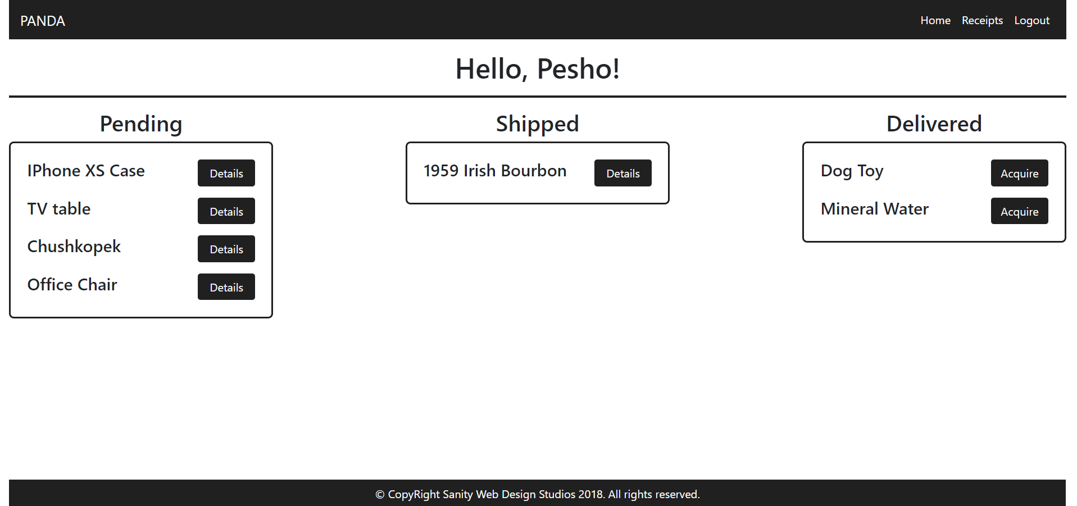

#### Package Details Template (route=”/Packages/Details?id={id}”) (logged in user)

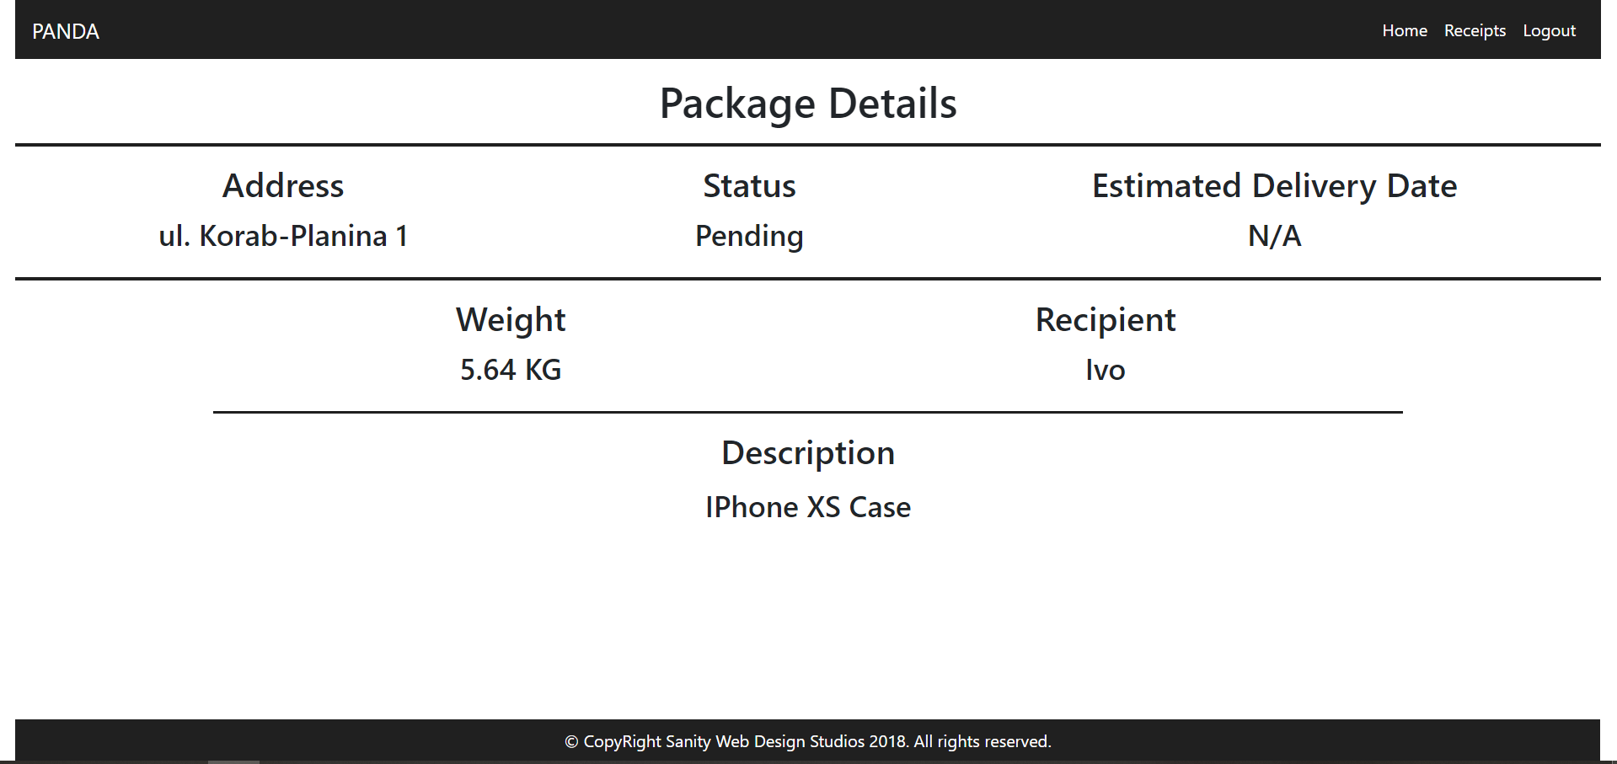

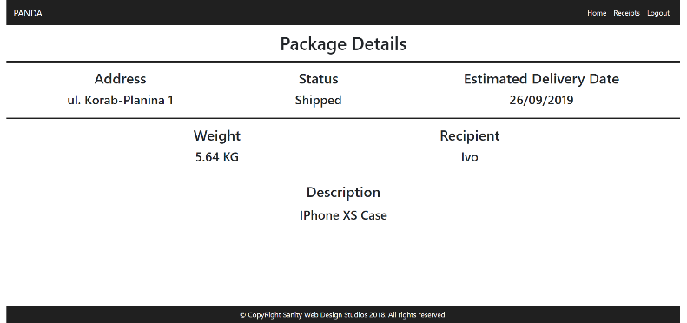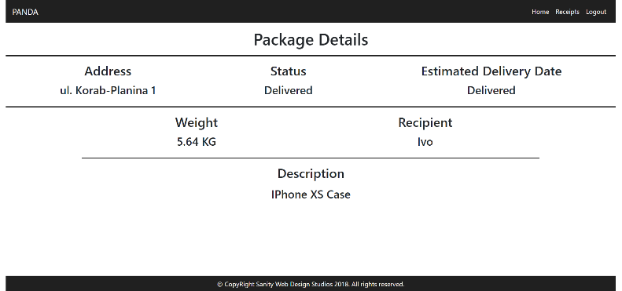

**NOTE**:

* If the **package’s status** is Pending, it should **NOT** have an Estimated Delivery Date, and “N/A” should be presented.
* If the **package’s status** is Shipped, it will have an Estimated Delivery Date. In that case the **date** should presented instead of “N/A”. (Example: “29/02/2016”).
* If the **package’s status** is Delivered or Acquired, instead of the **date**, “Delivered” should be presented.

#### Receipts Template (route=”/Receipts/Index”) (logged in user)

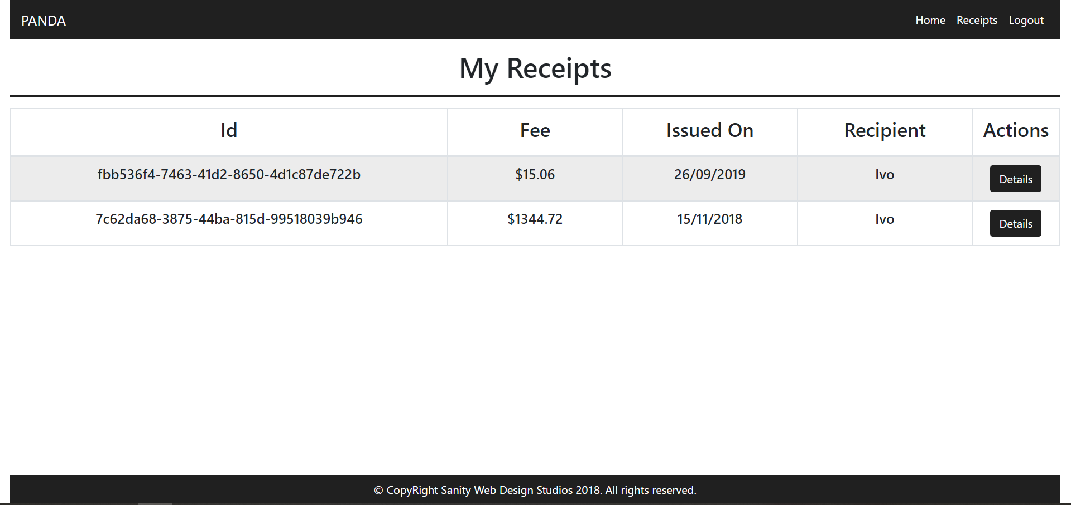

#### Receipt Details Template (route=”/Receipts/Details?id={id}”) (logged in user)

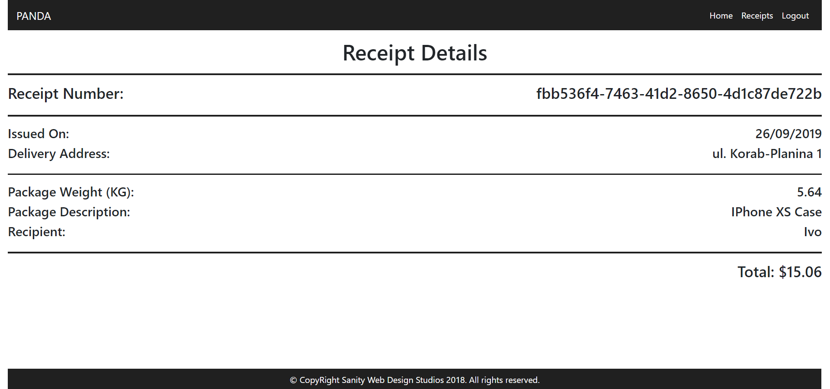

### Admin Templates

These are the **templates** and **functionalities**, accessible by Admins (**logged in** users with Role - Admin).

#### Admin Index Template (route=”/Home/Index”) (logged in admin)

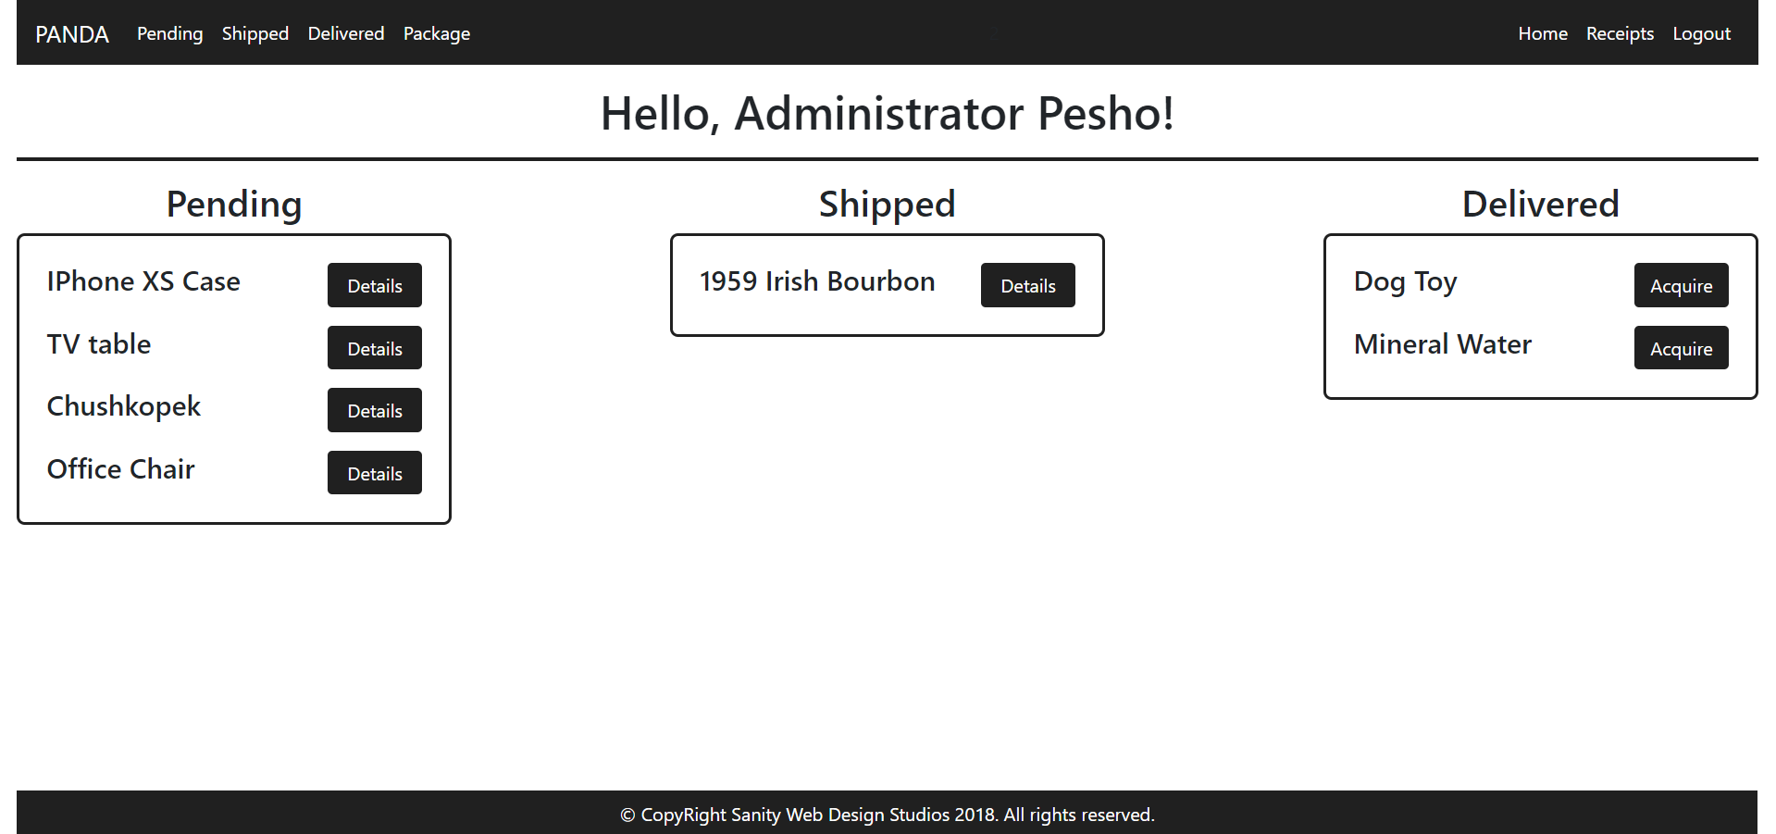

The navigation links above should lead to:

* [**Pending**] – **Pending Packages**
* [**Shipped**] – **Shipped Packages**
* [**Delivered**] – **Delivered Packages**
* [**Package**] – **Create Package**

#### Package Details Admin Template (route=”/Packages/Details?id={id}”) (logged in admin)

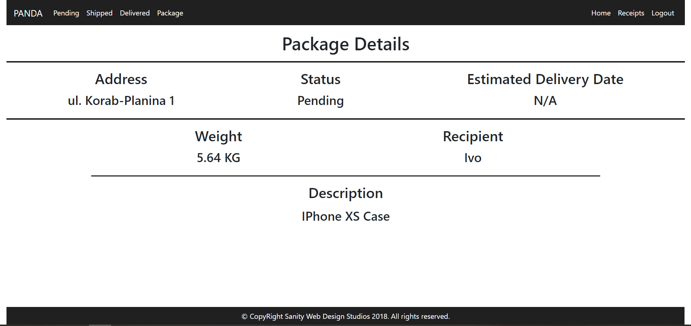

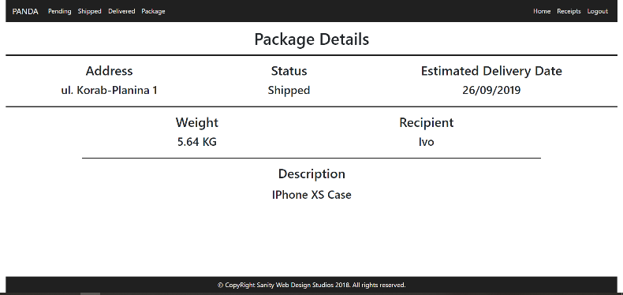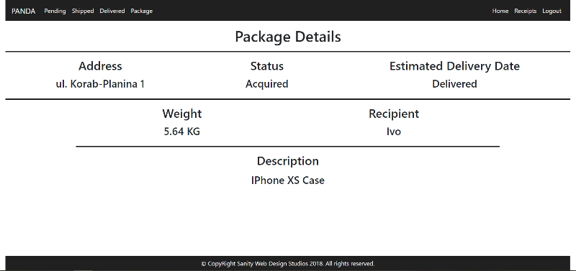

**NOTE**:

* If the **package’s status** is Pending, it should **NOT** have an Estimated Delivery Date, and “N/A” should be presented.
* If the **package’s status** is Shipped, it will have an Estimated Delivery Date. In that case the **date** should presented instead of “N/A”. (Example: “29/02/2016”).
* If the **package’s status** is Delivered or Acquired, instead of the **date**, “Delivered” should be presented.

#### Receipts Admin Template (route=”/Receipts/Index”) (logged in admin)

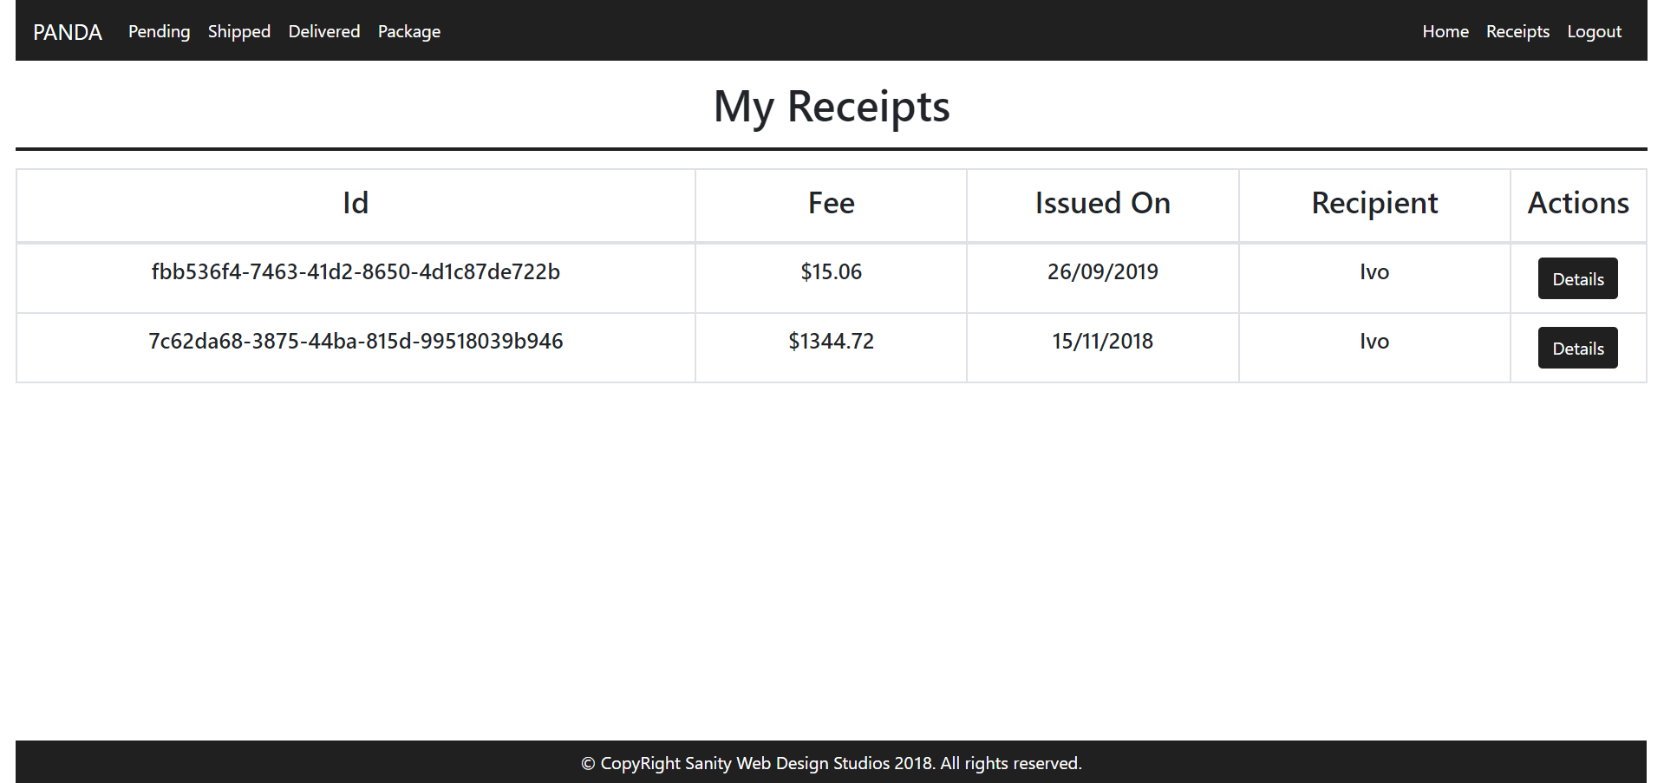

#### Receipt Details Admin Template (route=”/Receipts/Details?id={id}”) (logged in admin)

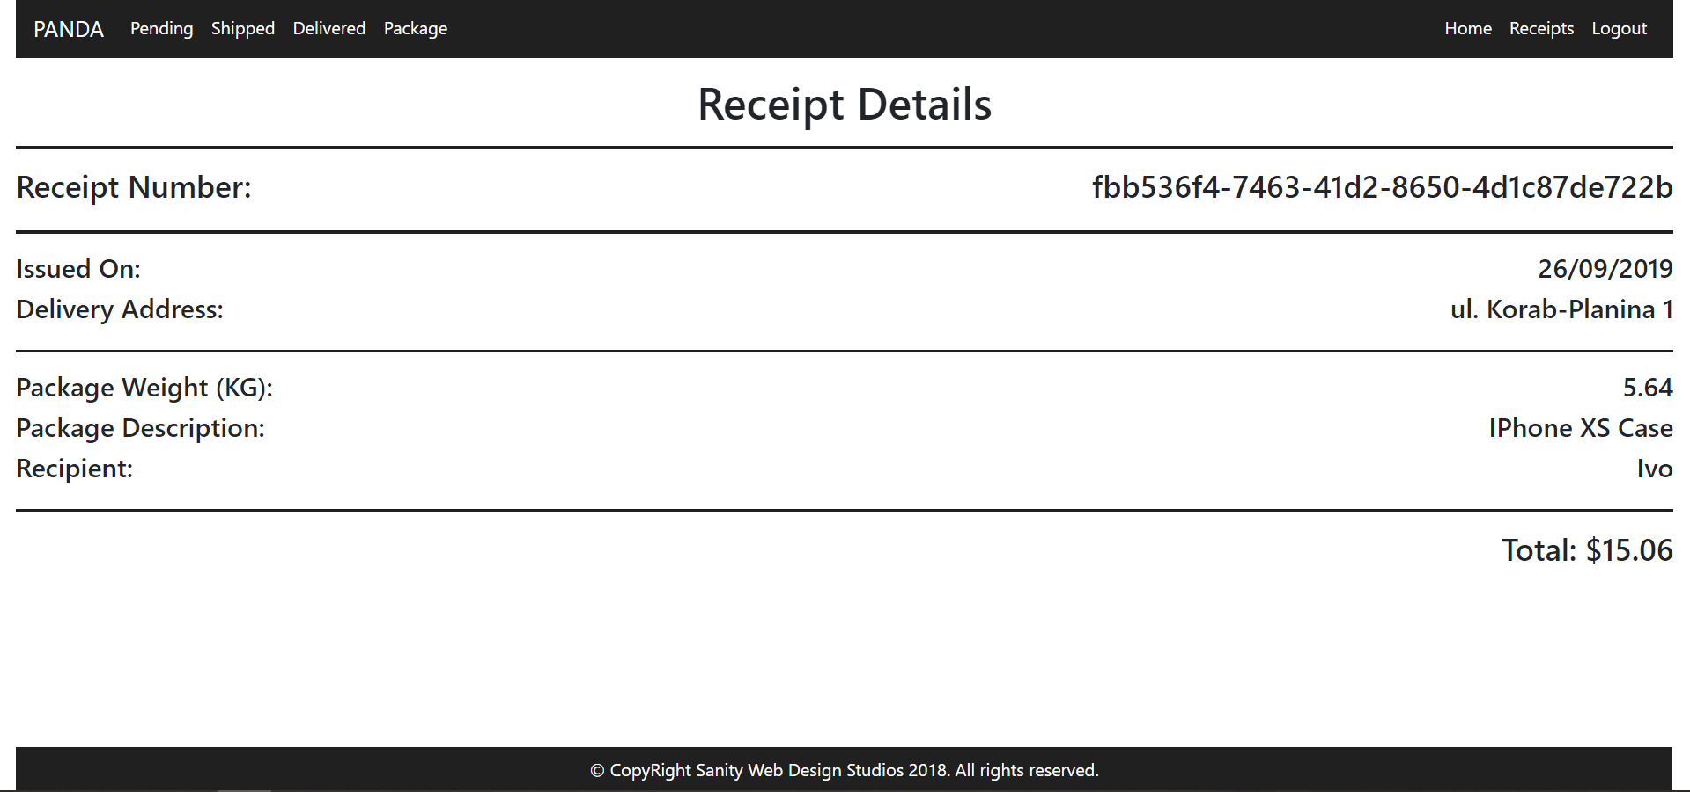

#### Package Create Admin Template (route=”/Packages/Create”) (logged in admin)

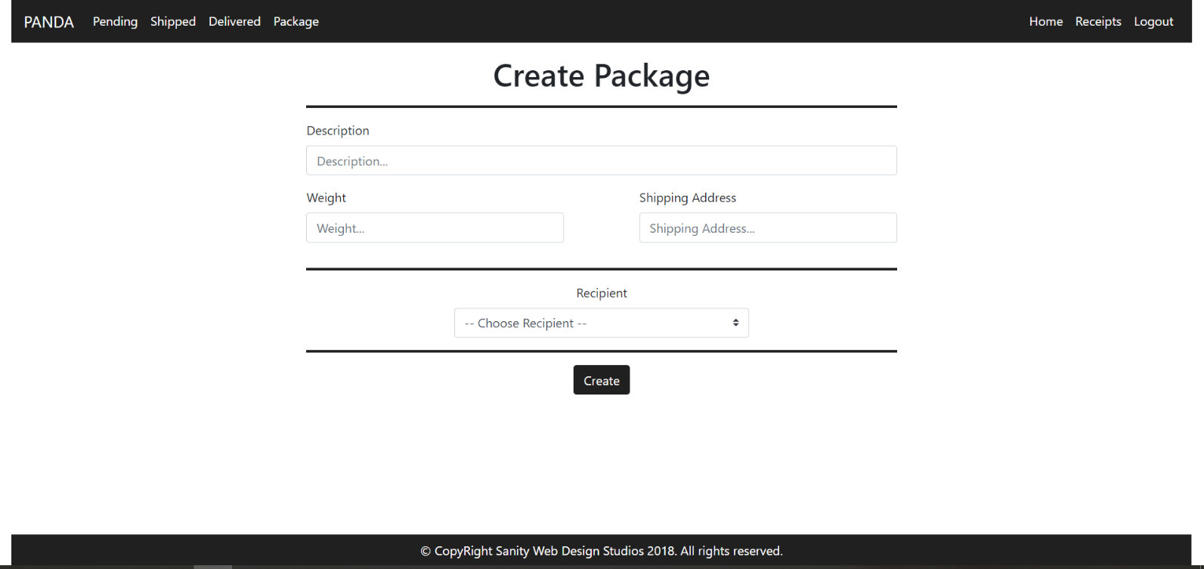

**NOTE**: The **Recipients** field is a **dropdown** **menu**, with **all the registered users** in the **application** (including **yourself**). The **primarily selected** **option** should be “-- Choose Recipient --" and it should be **disabled**, so that it **cannot** be **selected**.

#### Pending Packages Admin Template (route=”/Packages/Pending”) (logged in admin)

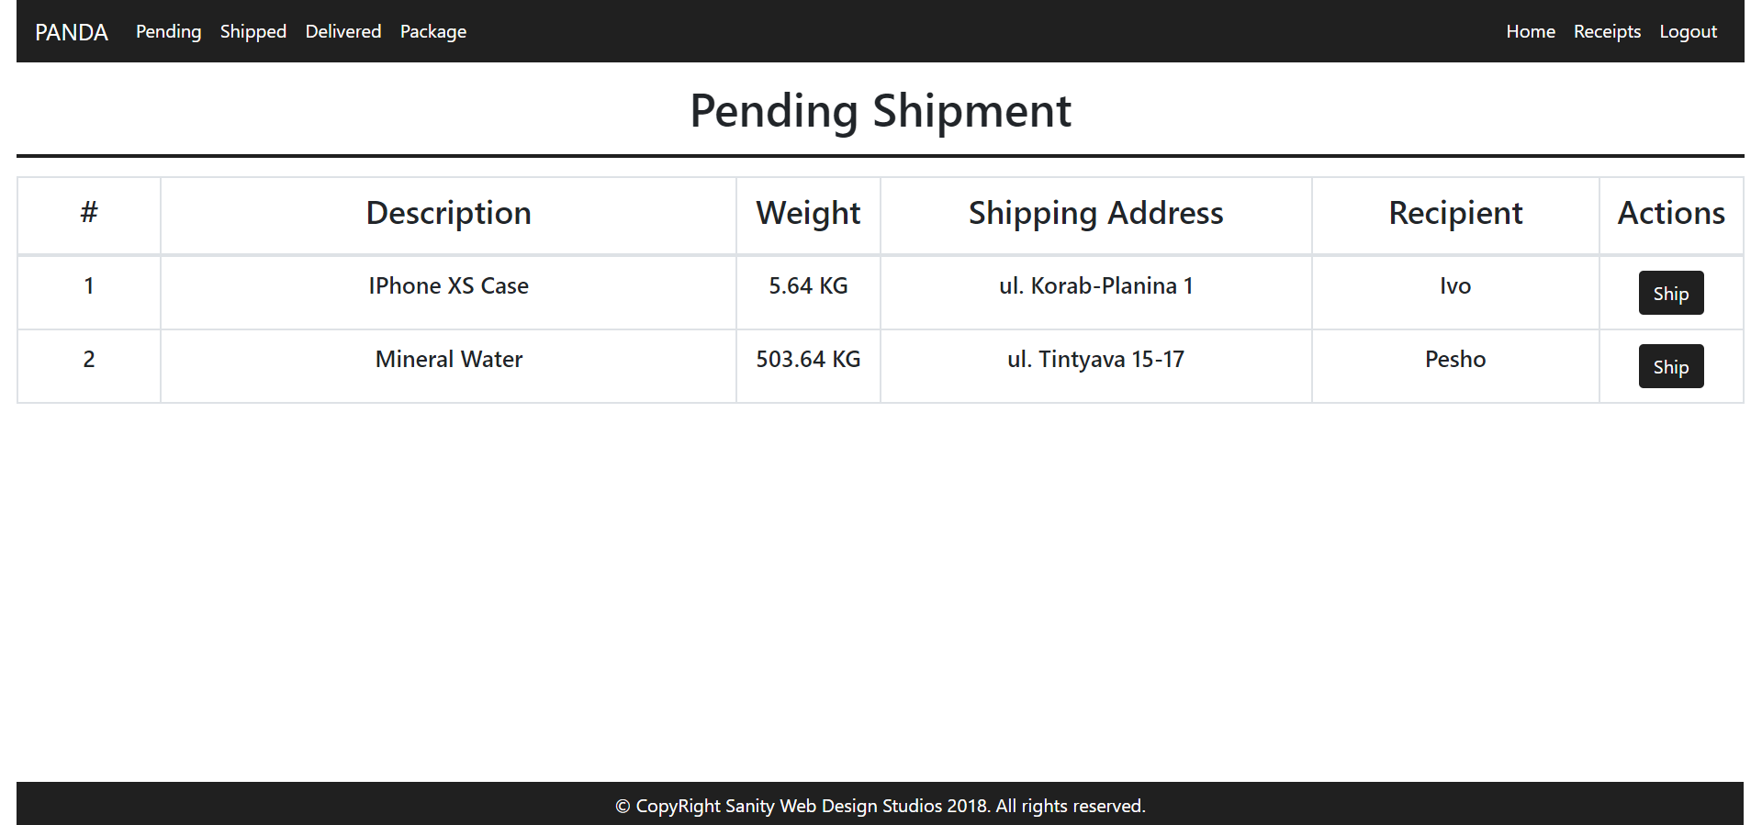

#### Shipped Packages Admin Template (route=”/Packages/Shipped”) (logged in admin)

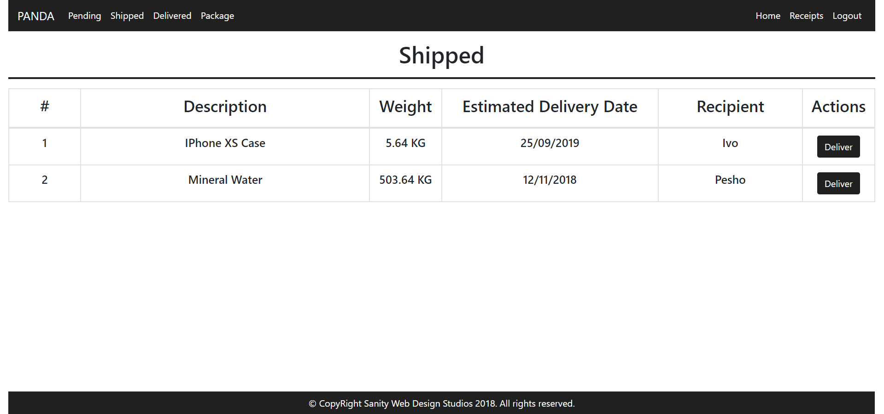

#### Delivered Packages Admin Template (route=”/Packages/Delivered”) (logged in admin)

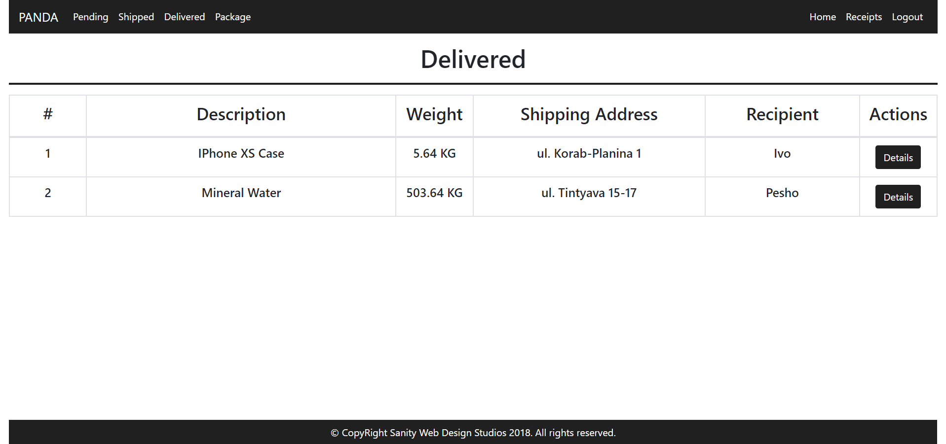

Some of the templates have been given to you in the application skeleton, but the others will be for you to implement, so make sure you implement them correctly. You can use the given ones as helpers.

**NOTE**: The templates should look **EXACTLY** as shown above.

**NOTE**: The templates do **NOT** **require** **additional** **CSS**. Only **bootstrap** and the given **style.css** are enough.

**NOTE**: In the given **style.css** you’ll see some helpful classes “bg-panda”, “text-panda”, “border-panda”. “border-panda” will help you with the **border** of the **blocks** on the **Index Pages**.

## Functional Requirements

The Functionality Requirements describe the functionality that the **Application** must support.

The **application** should provide Guest (not logged in) users with the functionality to:

* Login
* Register
* View the Guest Index page

The **application** should provide Users (logged in) with the functionality to:

* Logout
* View their Packages
* View details about a Package
* View their Receipts
* View details about a Receipt

The **application** should provide Admins (logged in, with role - Admin) with the functionality to:

* Logout
* View their Packages
* View details about a Package
* View their Receipts
* View details about a Receipt
* View all Pending Packages
* View all Shipped Packages
* View all Delivered Packages
* View details about all Delivered Packages
* Ship Packages
* Deliver Packages

### Users

The **first registered** User, should be **assigned** a **role** – “Admin”. Every User after that, should have a **role** – “User”.

Users have Packages, which are **created** and **controlled** for them, by an Administrator. Users can **view** **Details** about their **own** Packages. When a Package is **delivered**, a User can **acquire** it, at which point a Receipt is **created** with **that** Package and **that** User. Users can **view** their Receipts, and **details** about each Receipt.

Administrators (role = “Admin”) are essentially like normal Users. They can also have Packages, which are **delivered**, **acquired** and they also have Receipts. Administrators can also **create** Packages for a specific User.

* They can also **view** all Pending Packages, and they can Ship them.
* They can also **view** all Shipped Packages, and they can Deliver them.
* They can also **view** all Delivered Packages, and they can view Details about them.

### Packages

When Packages are **created**, they are **created** with a Description, a Weight, a Shipping Address and a Recipient User.

* Upon creation, the Status of a Package should be set to Pending.
* Upon creation, the Estimated Delivery Date of a Package should be set to NULL.

#### Functionality

##### Pending Packages

A Pending Package, can be Shipped by an Administrator, by clicking on the [Ship] button from the Pending Packages Page. At that moment the Package Status becomes “Shipped” and the Estimated Delivery Date is to be set to a **random** of **20**-**40** days from then.

* All Pending Packages are presented on the Pending Packages Page.
* A User can view his Pending Packages on his Index Page in the Pending rectangular block.
* A User can **view details** about each one of his Pending Packages from his Index Page, by clicking on the [Details] button.

##### Shipped Packages

A Shipped Package, can be Delivered by an Administrator, by clicking on the [Deliver] button from the Shipped Packages Page. At that moment the Package Status becomes “Delivered”.

* All Shipped Packages are presented on the Shipped Packages Page.
* A User can view his Shipped Packages on his Index Page in the Shipped rectangular block.
* A User can **view details** about each one of his Shipped Packages from his Index Page, by clicking on the [Details] button.

##### Delivered Packages

A Delivered Package, can be Acquired by the Package’s Recipient, by clicking on the [Acquire] button from his Index Page. At that moment the Package Status becomes “Acquired” and a Receipt is **generated** to the User for that Package.

* All Delivered Packages are presented on the Delivered Packages Page.
* A User can view his Delivered Packages on his Index Page in the Delivered rectangular block.
* A User can Acquire each one of his Delivered Packages from his Index Page, by clicking on the [Acquire] button.

**NOTE**: The **INDEX PAGE** visualizes **ONLY** the **CURRENTLY LOGGED IN USER / ADMIN’s** **PACKAGES**.

**NOTE**: Acquired Packages are viewable only by Administrators on the Delivered Packages Page.

**NOTE**: Administrators can **view** **details** about **ALL** Delivered / Acquired Packages from the  
Delivered Packages Page, by clicking on the [Details] button.

### Receipts

Receipts are just data entities. They are **created** when a Package is Acquired by its Recipient User.   
A Receipt should be **created** with a Package and a Recipient User.

Upon creation, a Receipt’s Fee should be **set** to the Package’s Weight **multiplied** (*) by 2.67.

Upon creation, a Receipt’s IssuedOn should be set to the **current moment**.

## Security Requirements

The Security Requirements are mainly access requirements. Configurations about which users can access specific functionalities and pages.

* Guest (not logged in) users can access Index page and functionality.
* Guest (not logged in) users can access Login page and functionality.
* Guest (not logged in) users can access Register page and functionality.
* Users (logged in) can access User LoggedIn Index page and functionality.
* Users (logged in) can access User Package Details page and functionality.
* Users (logged in) can access User Receipts page and functionality.
* Users (logged in) can access User Receipt Details page and functionality.
* Users (logged in) can access User Package Acquire functionality.
* Users (logged in) can access Logout functionality.
* Admins (logged in) can access **every functionality** a **normal** logged in User can.
* Admins (logged in) can access Admin LoggedIn Index page and functionality.
* Admins (logged in) can access the Admin Package Create page and functionality.
* Admins (logged in) can access the Admin Pending Packages page and functionality.
* Admins (logged in) can access the Admin Shipped Packages page and functionality.
* Admins (logged in) can access the Admin Delivered Packages page and functionality.
* Admins (logged in) can access the Admin Package Ship functionality.
* Admins (logged in) can access the Admin Package Deliver functionality.

## Scoring

This section describes how the scoring of the Exam will be made.

### Database Requirements – 10 points.

### Template Requirements – 30 points.

### Functional Requirements – 50 points.

### Security Requirements – 10 points.